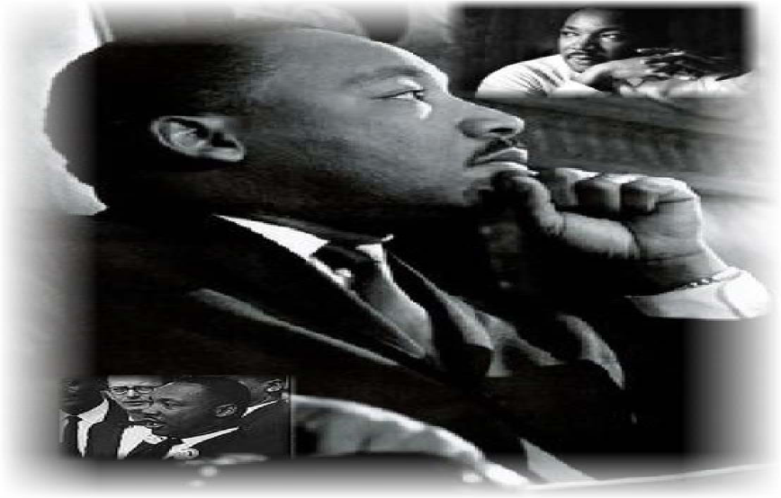

The purpose of the Martin Luther King, Jr. scholarship is to offer financial assistance, up to $1,500 cash award, to undergraduate college or trade school students who are committed to Christian-inspired action in: (1) inner city (urban) settings and/or (2) social action through peace and justice. College- or trade-school bound high school seniors are encouraged to apply.
Criteria for scholarship recipients:
- An active member of a recognized congregation of the Pacific Southwest Region Christian Church (Disciples of Christ);
- Registered for full-time undergraduate studies in an accredited university, community college, trade school, or equivalent educational program;
- Able to demonstrate financial need upon request;
- Recommended for leadership potential by his/her pastor, Church Board Leader, Youth Group Leader or school counselor.
APPLICANT:
- Please complete all sections of the scholarship application. Answer all questions fully. Incomplete applications will not be considered.
- Writing must demonstrate the ability to clearly express oneself. Provide clear, succinct and purposeful information that addresses each question. Application must include an English version of your response if you choose to write your essay in another language.
- A letter of recommendation from a local church congregational leader (Board or Youth Pastor), pastor, school counselor or college advisor must be attached to the application. Ask someone who knows you well!
- Your school enrollment will be verified with the registrar’s office. Be sure to list accurate university phone number, contact person and their e-mail address.

Deadline for submitting completed applications: December 31.

Email completed application to: Church in Society at CIS@docpswr.org
and j.bynum@docpswr.org
Scholarship recipients will be notified in January.
As part of scholarship acceptance, winners should be prepared to read and/or elaborate their essay responses.

PERSONAL DATA

Full Legal Name_______________________________________________________
Residential Address
(Street)

(City) (State) (Zip)

Primary Telephone Other Phone

E-mail address

SCHOOL INFORMATION

Name of current college/university or trade school

_____________________________________________________________________

School Address______________________________________________________________
(Street)

(City) (State) (Zip)

Office of the Registrar phone ______________________________ EXT__________

Contact Person __________________________________Title__________________

E-mail address___________________________ Undergraduate Status___________

PSWR CHURCH AFFLIATION

Home Church _____________

Church Telephone Number _____________

Pastor’s Name _____________

How long have you been a member of this congregation? ____________________

Short Answer Essay (200-500 words)

Instructions: In your own words, tell us of an experience, either one that happened to you personally or one you observed that aided your understanding of the complexities of racism or injustice.

In your essay, please ensure that you tell us:
- What the experience taught you, and
- How the scholarship award will help you advocate for racial harmony, social justice and peace.

I certify that the information provided is true and complete to the best of my knowledge.

Signed _________________________________________Date __________________

